**Create Dashboards**

1.Click the Dashboards tab.  
2.Click New Dashboard.  
3.Name the Properties with Customer Name Report and click Create.  
4.Click +Component.  
5.Select the Properties with Customer Name Report and click Select

6.Select the Vertical Bar Chart component(select in which format you want display chart and click Add.  
7.Click Save and then Done.

### Create Dashboards

Follow the above steps  
1.Create the Dashboard for the Same Take Any Type of Dashboard(Chart) And Display Iton The App Home Page

**Report**

1. Click on App Launcher on left side of screen
2. Search property management & click on it.
3. Click on Reports Tab.
4. Click on Properties with Customer Name & see records
5. **Dashboard**
6. Dashboards help you visually understand changing business conditions so you can make decisions based on the real-time data you’ve gathered with reports. Use dashboards to help users identify trends, sort out quantities, and measure the impact of their activities. Before building, reading, and sharing dashboards, review these dashboard basics.
7. **View Dashboard**
8. 1.Click the Dashboards tab.  
   2.Click New Dashboard.  
   3.Name the Properties with Customer Name Report and click Create.  
   4.Click +Component.  
   5.Select the Properties with Customer Name Report and click Select

6.Select the Vertical Bar Chart component(select in which format you want display chart and

7.Click Save and then Done.

**Classic Email Template**

**Classic Email Template**

**Note**: For creating this flow you have to create the Due date for Loan Payment

field in the loan object with date and time field data type

Go to the Gear Icon?Click on the home button and Search for the Classic Email Template

?Click on the New Template? name?oan Amount Pay Reminder

Author as the System admin user?give Description?Reminder Calls through emails

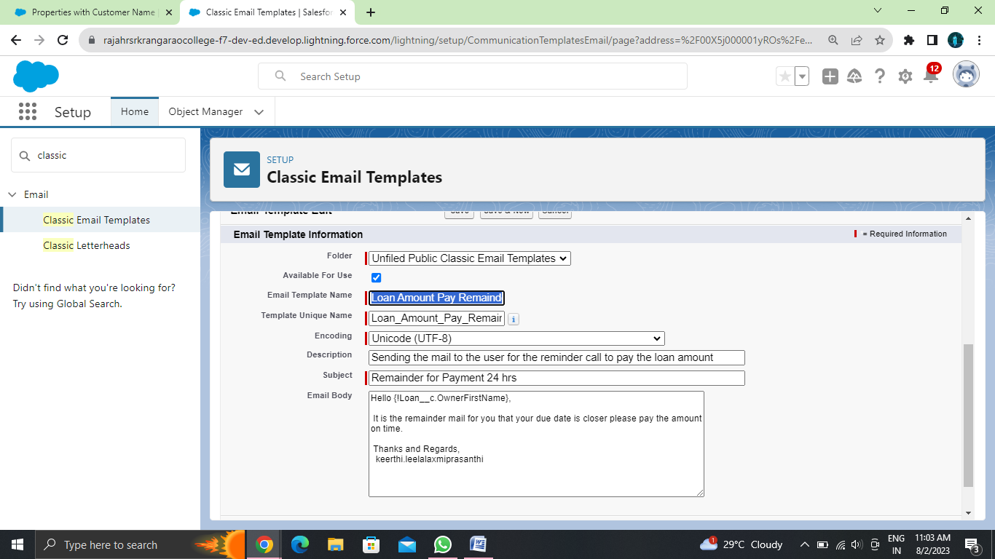

### Create The Email Alerts

Click on the home button and search for the Email Alerts  ---> There Click on the New Email alerts

 ---->and give the name as Email For the 24 hrs before---> select the email template which you have

created for the 24 hrs before

There Click on the New Email alerts---->  and give the name as Email For the 24 hrs before

---->select the email template which you have created for the 24 hrs before and recipient

for all condition is owner

Follow the Above steps and create the Following Email Alert by cloning with the Similar steps

1. Loan Amount Pay Reminder(Cloned Email Alert)

2. Overdue by one day(Cloned Email Alert)

3. Overdue(Cloned Email Alert)

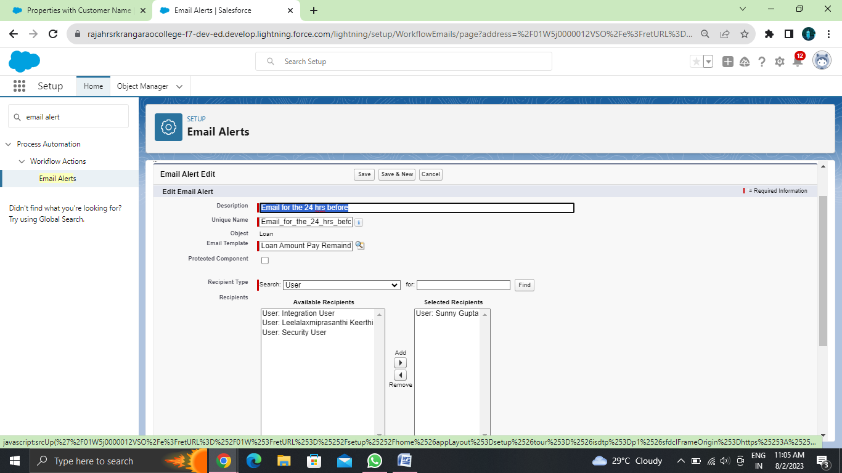

### Create The Flows

* Go to the Home Button and search for the flow

Click on the New Flow---->Click on the Record Trigger Flow

* Select the loan__c object----> Trigger the Flow When----> A Record is created or update
* Condition Requirement?All Conditions are met (AND) ----> Field---->Due Date For the Loan PaymentOperator as --->is Nullvalue False
* Click on the Schedule path----> Path Label as---->within 1 Day----> API Name within_1_day?

               Time Source? Loan__c:Due Date Loan payment ---> Offset number 24----> offset option

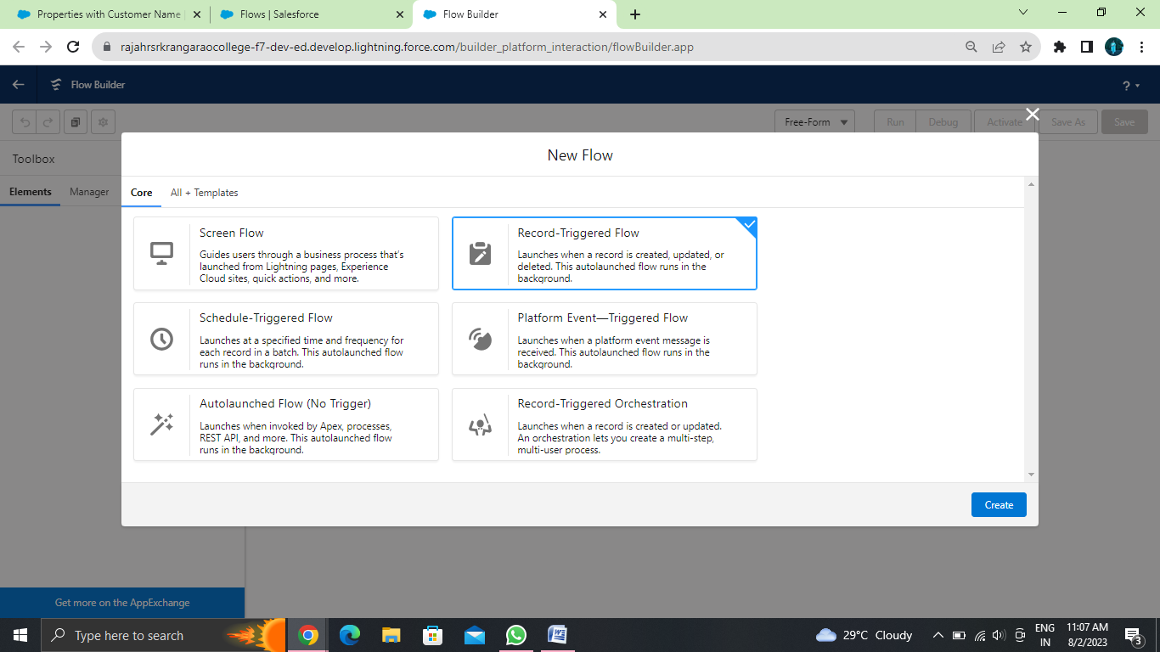

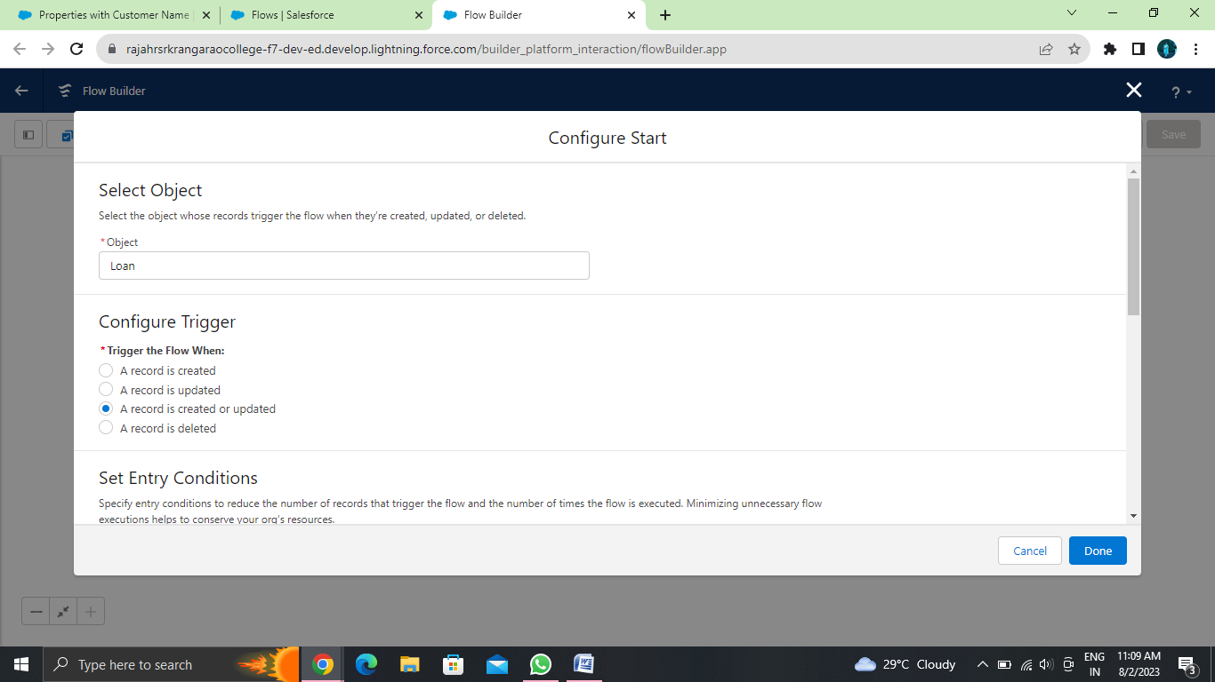

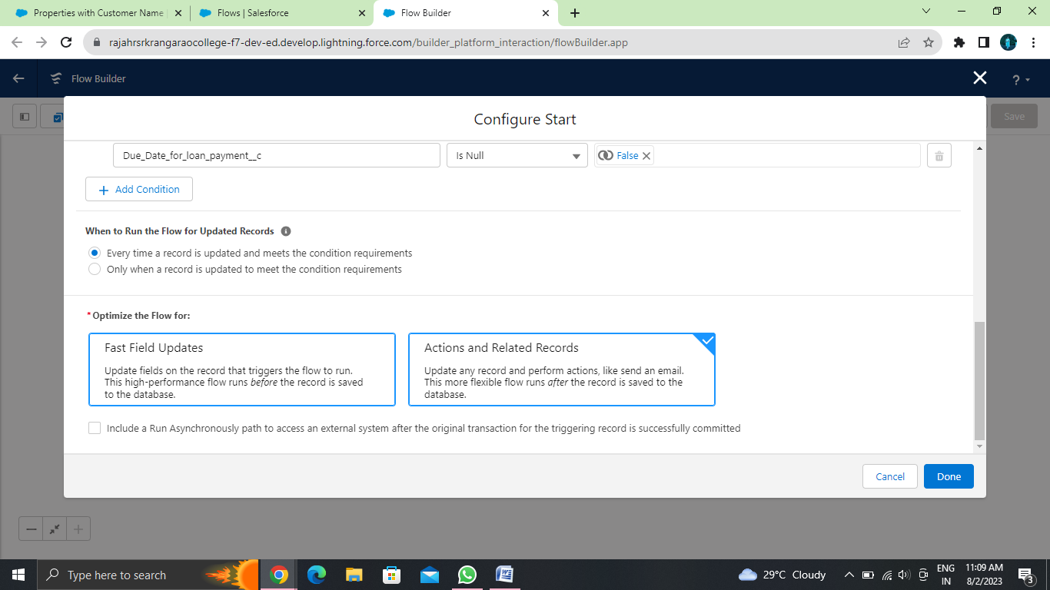

### Decision Element

* Than There is Decision for the just click on add----> select the Decision--->order outcomet--->here are two outcome 1. Send Email 2. don’t send the email
* On the outcome is there is the condition for that label don the send email ----> condition Requirement All Conditions are met (AND) ? Operator less than 1
* Follow the same steps for the Following
* On the outcome is there is the condition for that label done the send the email---> condition Requirement All Conditions are met (AND) ----> Operator less than 5
* On the outcome is there is the condition for that label Dont send email for this ----> condition Requirement All Conditions are met (AND) ----> Operator Greater than 0
* On the outcome is there is the condition for that label Dont Send the Email for this ----> condition Requirement All Conditions are met (AND) ----> Operator Greater than 1

1. Go to the layouts change the auto layout with the free for delete both the thread for each decision and create one new connection thread similarly do for all threads and come back to auto layout

### Create The Record To Test The Flow

Go to the App Launcher and select the property management application than Go to the Loan Object create one record with the following values Go to you personal email you will get the mail for the selected date

Here you can see the mail for the 24 hrs before the condition is like duedate – created for the remaining days so it will trigger the email accordingly

### Trigger

**Use Case:** Apex Trigger is Related  to Property Object in that there is the field “Create Property Type” which is having the picklist values in that field(Residential, Commercial, Industrial) the condition is like if we select the Create Property type as “Residential” than there is  Commercial field so it should get populated with “Shop”

**Apex Class:**

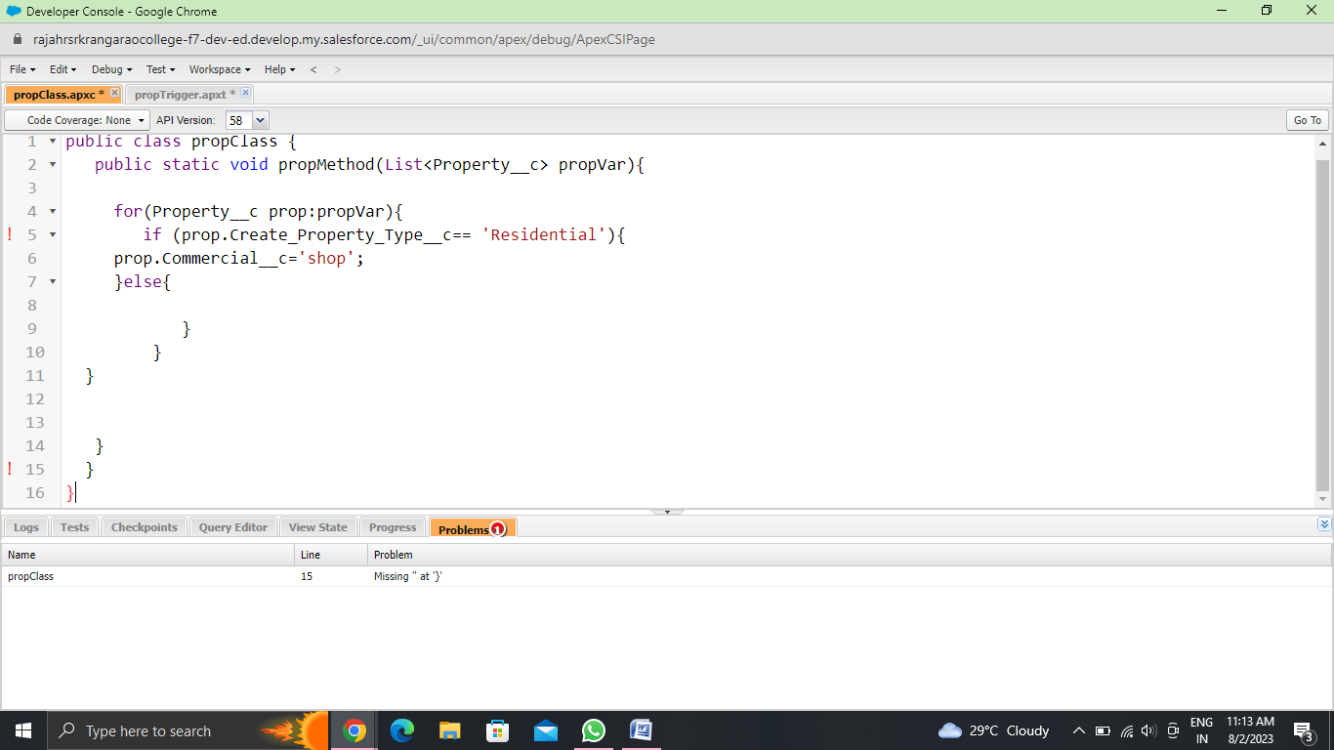

public static void propMethod(List<Property__c> propVar){

public class propClass {

    for(Property__c prop:propVar){

        if (prop.Create_Property_Type__c== 'Residential'){

            prop.Commercial__c='shop';

        }else{

        }

        }

        }

}

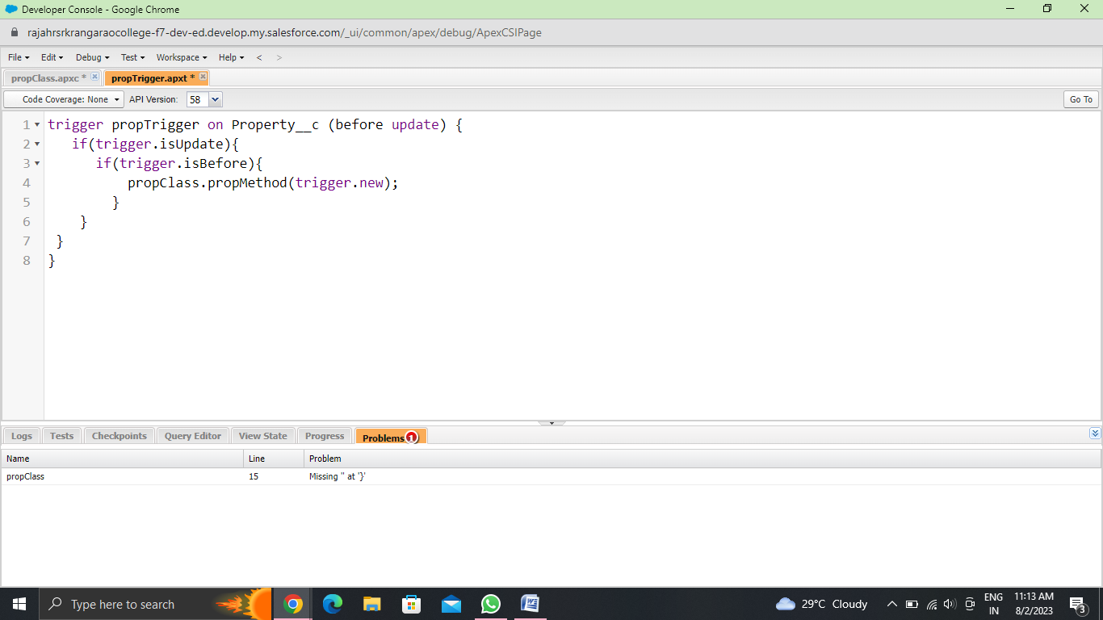

trigger propTrigger on Property__c (before update) {

    if(trigger.isUpdate){

        if(trigger.isBefore){

propClass.propMethod(trigger.new);

    }

    }

    }

* Just Go to the Property Object and Check Whether Your Trigger Is Working or not as per the requirement